**Tutorial 13: Component Styles & Global Styles**

When we add styles in the styles tag they will automatically apply to all components. By adding a scoped attribute on the styles within that component will be styled and will not affect the styling of the other components.

Look at the example below (**Line 10**):

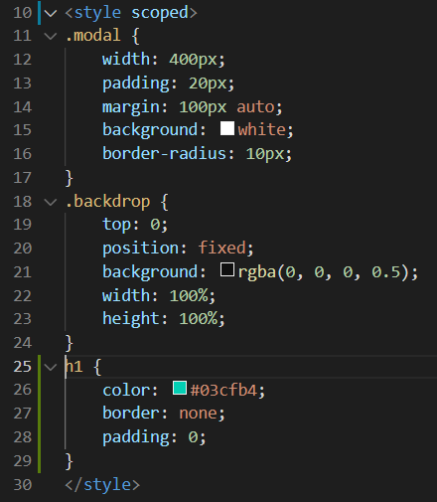

If you want to have a global styles that apply to common elements that appear in multiple different components, what you could do is create a global style sheet inside the assets folder.

Make sure **Tutorial 12** is complete to be able to move on to this tutorial or clone the [vue3-firebase-course](https://github.com/younggrasshopperza/vue3-firebase-course) repository and go to branch called **Tutorial-12**.

**Step 1:** In the assets folder create a file called **style.css**. Add the following CSS code below:

body {

    margin: 0;

}

p {

    font-style: italic;

}

**Step 2:** In **main.js**, import the file **style.css** file.

Look at the example below (**Line 3**):

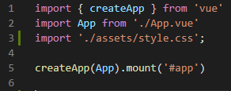

**You can view the code snippets from the** [**vue3-firebase-course**](https://github.com/younggrasshopperza/vue3-firebase-course) **repository under the Tutorial-13 branch.**